Meeting Notes

# Wednesday, March 30, 2016

|  |  |  |
| --- | --- | --- |
| **Start Time** |  |  |
| **Members** |  |  |
| **Adjournment Time** |  |  |

## *Purpose of Meeting*

*To discuss possible methods of communication through software services, priority of module development, and “kick-off” project initiatives*

Agenda:

Relay comments about current progress of the project

* Items to complete
* In progress
* What we can move forward with

Present possible communication methods

* Sharepoint
* Slack

Present and discuss possible Project Management Software

* MS Project – License?
* Asana

Project Content

* Priority of Modules
* Finalize deadline for first module
* Documents to complete

Possible Committee

* Committee Size and Organization

Slack:

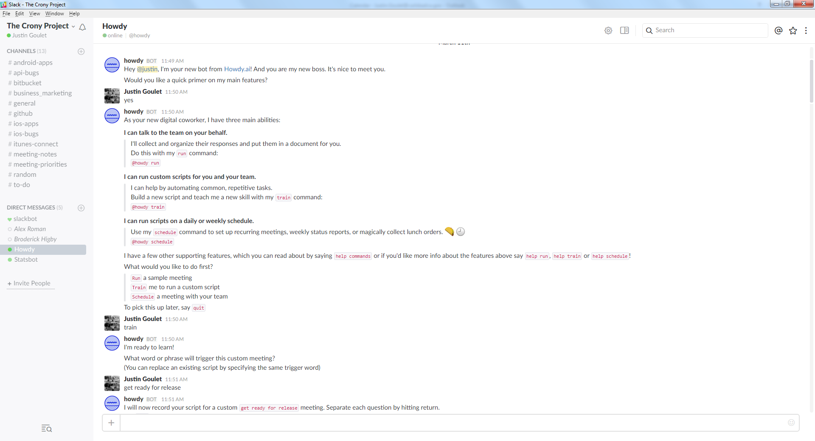

Asana:

